How to make an observation with the RTI

1. Log into the RTI, which can be accessed from​ ​​https://rti.lco.global

Paste​ ​the​ ​provided​ ​token​ ​into​ ​the​ ​field​ ​shown ​and​ ​click​ ​the​ ​BEGIN​ ​SESSION​ ​button.

This​ ​navigates​ ​to​ ​the​ ​RTI​ ​Observing​ ​screen.​ ​​ ​If​ ​the​ ​current​ ​time​ ​is​ ​not​ ​between​ ​5​ ​minutes​ ​before and​ ​15​ ​minutes​ ​after​ ​the​ ​valid​ ​slot​ ​for​ ​which​ ​the​ ​token​ ​has​ ​been​ ​generated,​ ​an​ ​error​ ​message will​ ​be​ ​returned.

2. Select​ ​“List”​ ​in the​ ​Target​ ​Input​ ​Mode​ ​and​ ​select​ ​the​ ​desired​ ​target​ ​from​ ​the​ ​list​ o​​r​ ​​select “Manual”​ ​in the​ ​Target​ ​Input​ ​Mode​ ​and​ ​type​ ​a​ ​Target​ ​Name,​ ​Right​ ​Ascension,​ ​and Declination​ ​into​ ​the​ ​labeled​ ​boxes.

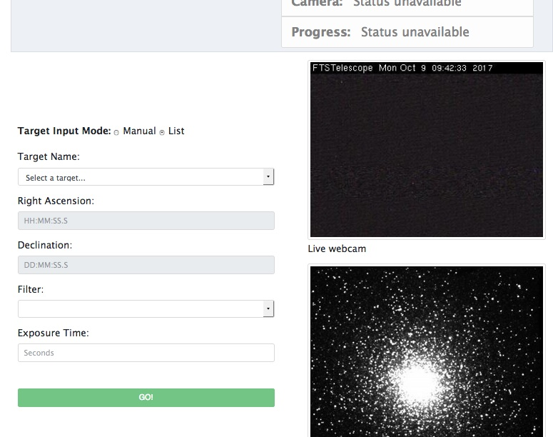

3. Select​ ​a​ ​filter​ ​using​ ​the​ ​pull-down​ ​menu​ ​and​ ​enter​ ​an​ ​exposure​ ​time​ ​into​ ​the​ ​box between​ ​1​ ​second​ ​and​ ​the​ ​number​ ​of​ ​seconds​ ​remaining​ ​in​ ​the​ ​session.​ ​

For​ ​objects from​ ​the​ ​list,​ ​recommended​ ​exposure​ ​times​ ​will​ ​appear​ ​when​ ​the​ ​filter​ ​is​ ​selected.​ ​The recommended​ ​exposure​ ​times​ ​can​ ​be​ ​modified​ ​if​ ​deemed​ ​necessary.

4. When​ ​the​ ​Progress​ ​status​ ​field​ ​is​ ​“READY”,​ ​click​ ​the​ ​GO!​ ​Button.​ ​​ ​The​ ​PROGRESS status​ ​should​ ​change​ ​to​ ​EXECUTING​ ​REQUEST,​ ​the​ ​telescope​ ​will​ ​move​ ​to​ ​the requested​ ​position,​ ​and​ ​the​ ​camera​ ​will​ ​begin​ ​exposing.​ ​​ ​A​ ​countdown​ ​will​ ​appear​ ​to​ ​the right​ ​of​ ​the​ ​Camera​ ​Status:​ ​EXPOSING​ ​text.

5. When​ ​the​ ​exposure​ ​is​ ​complete,​ ​the​ ​camera​ ​status​ ​will​ ​change​ ​to​ ​READING_OUT,​ ​and then​ ​back​ ​to​ ​IDLE​ ​when​ ​readout​ ​is​ ​complete.

6. Follow the same procedure to choose another object to observe.

