Submitting an Observation Request to the LCO Interface
These step-by-step instructions will take you through how to use your Faulkes Telescope account to access the Las Cumbres Observatory (LCO) interface, and submit an observation request of an object of your choice. If the options below aren’t visible to you, check you are not using the ‘basic’ interface by clicking on your name, then profile and unselecting simple interface at the bottom of the page.
Step 1: To submit an observation on the Faulkes Telescope using the LCO network you will need to follow the link here: https://observe.lco.global/. This will take you to the screen shown in Figure 1.
Step 2: Select one of the ‘Login’ options circled in Figure 1 and input your username and password. Your username is usually your email address.
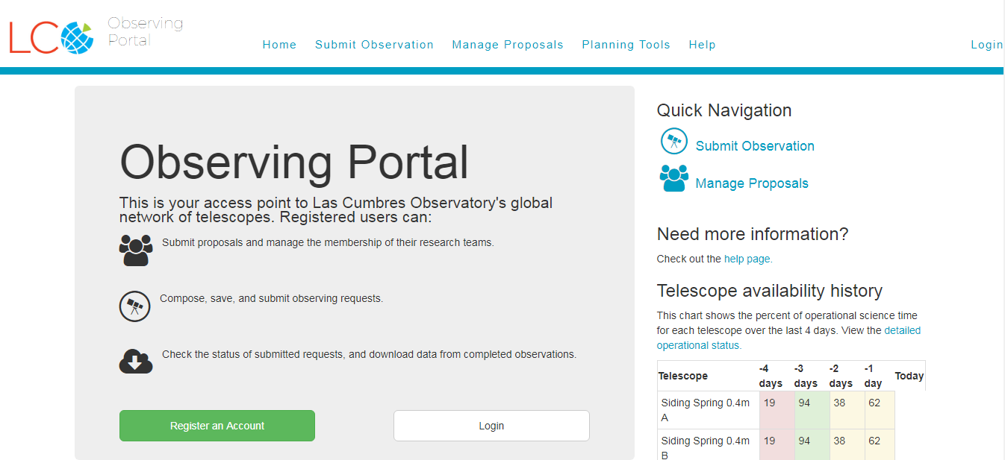
Figure 1 – Logging on to LCO’s observing portal

You’ll now be taken to a page that displays a lot of information. You don’t need to worry about most of this, just simply select ‘Submit Observation’ to request your observation as shown in Figure 2.
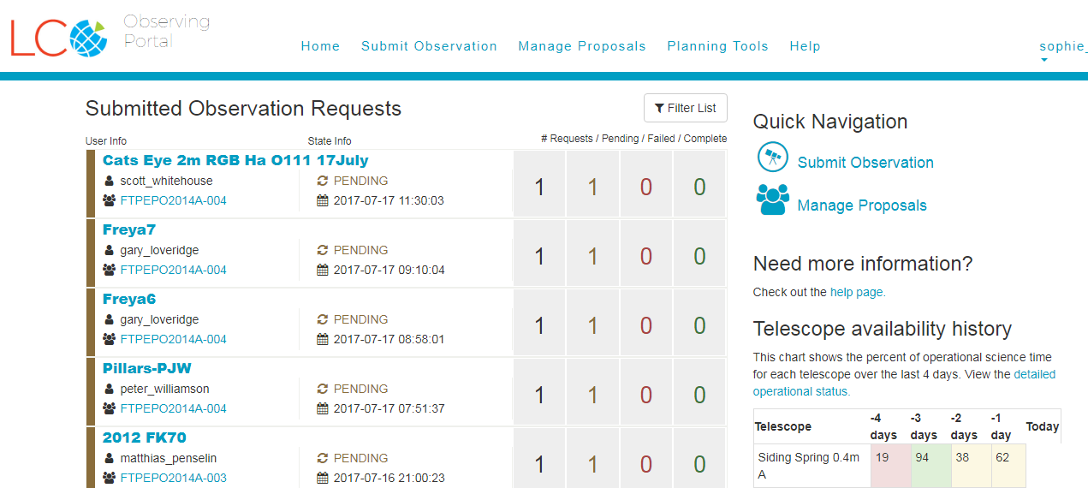
Figure 2 – Where to go to submit your observation

Your screen should now display the Observation Request Form. The following steps will take you through each section of this form.
Don’t panic if you see a lot of red error messages on the page. These will remain until you have completed all the information boxes.
General Information
This is the general summary section of your observation request.
Step 3: In the ‘Name’ box you should give your observation a suitable title that you will remember.
You may want to use your name or initials so that you can find your images easily once they’ve been taken.
Step 4: ‘Proposal’ refers to the telescope proposal you wish to take the observation time from. You should select ‘FTP Education – Queue’.
‘Mode’ and ‘IPP Factor’ can be left as the default settings. If you happen to get an error message next to the ‘IPP Factor’ you may need to reduce the value to 1 or lower, but you should be okay leaving it on 1.05.
Figure 3 – General information section of the observation request form
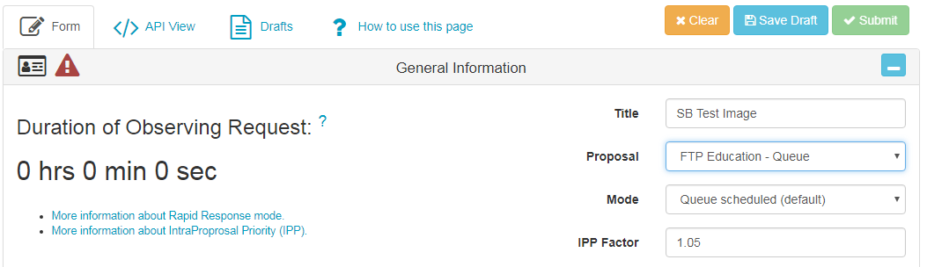

Request
Step 5: Next we have the Request section. Here you should select ‘Image’ as your observation type and the instrument you wish to use. You can choose from the three sizes of telescopes, 2-metre, 1-metre or 0.4-metre.
Figure 4 – Request section of the observation request form
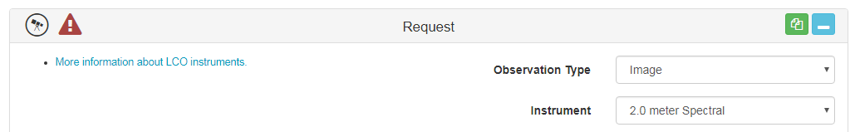

Target
The target section is where you fill in the details about the object you wish to image. The boxes circled in green in Figure 5 should be left as their default settings – you don’t need to worry about these.
Step 6: If you know the Messier or NGC number of your object, you should insert it in the ‘Target Name’ box, that way, it’s likely that the scheduler will be able to find the right ascension and declination for you automatically.
If the right ascension and declination values to not come up automatically, you will need to enter them yourself. You can search these coordinates on Stellarium or through a Google search of your object.
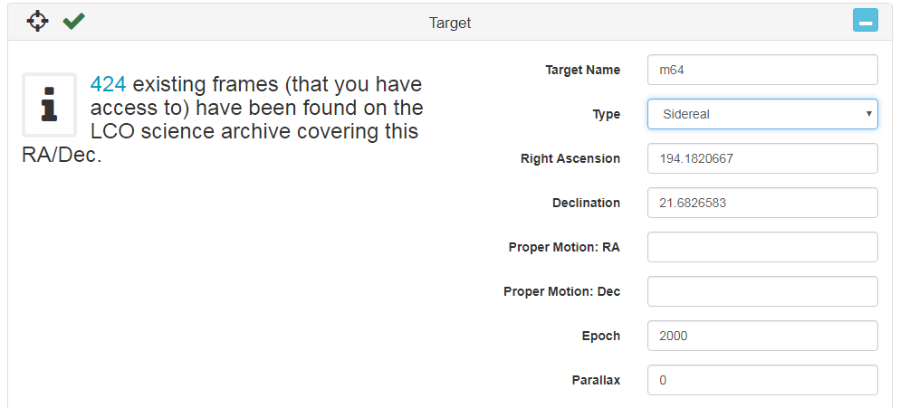
Figure 5 – Target section of the observation request form
Configuration
Step 7: In configuration, you will need to select the filters you wish to use. If you want a colour image you will need to select the B, V and R filters.
You can only select one filter at a time so begin by selecting ‘Bessell-B’.
Step 8: Leave ‘Exposure Count’ on 1 and enter your ‘Exposure Time’. If you’re unsure on what exposure time to use, you can follow the link to the LCO online Exposure Time Calculator provided on the left side of the configuration section, or you can use our guidelines here: http://www.faulkes-telescope.com/education/planning/exposures
You can leave ‘Defocus’ and ‘Guiding’ as their default setting.
Step 9: To add another filter, you will need to click the little green icon at the top of the window circled in red in Figure 6, this is ‘Copy’. It will replicate the details you have just inputted so you will need to change the filter, for example to Bessell-V and also adjust the exposure time if you need to.
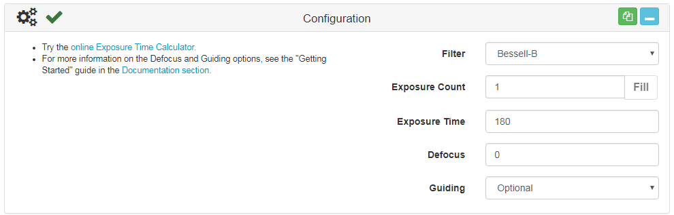
You can then repeat this for however many filters you wish to use.
Figure 6 – Configuration section of the observation request form

Note: for the 2-metre and 1-metre telescopes B, V, and R filters are the Bessell ones. If you are using a 0.4-metre you will need to select the SDSS-r’ filter for the red filter instead of Bessell.
Window
We now move onto the Window section. This describes the time window in which you would like your observation to be made.
Step 10: The time is set to Universal Time and the Start time will default to the current time. We recommend putting your End time a week later. This should be enough time for you observation to be made and not be cancelled due to either telescope or camera problems or bad weather.
If you’re lucky, the scheduler may even plan a time to image your object as little as 15 minutes after submitting your request. However, this can also change as other requests come in, so keep checking.
The graph that appears as displayed in Figure 7 shows you the visibility of your target in the time window you have set.
You don’t need to worry about the ‘Cadence’ for now so you can leave that set to ‘None’.
Figure 7 – Window section of the observation request form
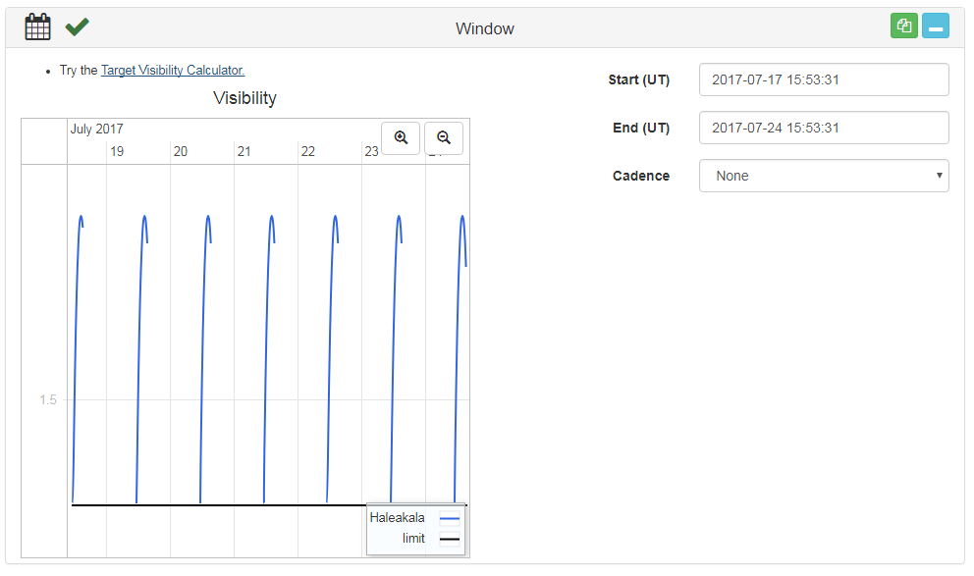
Constraints
This final section can be left as the default settings.
You have now completed the observation request form. If you scroll back to the top of the page it will tell you the duration of your request. This describes how much observing time it will take to take your observation.

Figure 8 – Duration of your observing request
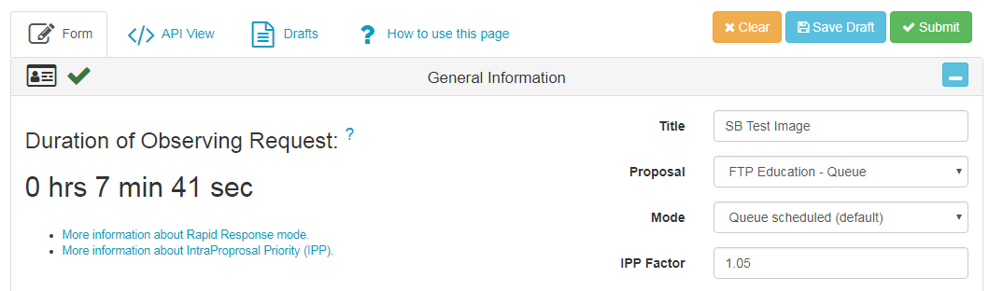
Step 11: If you would like to request observations of more than one object, you should scroll back to the ‘Request’ section. First of all, select the little blue icon in the top-right corner – this is minimise. Then select the green copy icon.
You should notice that this causes ‘Request #2’ to appear on the right hand side of your screen as seen in Figure 9.
Figure 9 – Your different requests within your observation request form
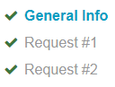
Step 12: By clicking on Request #2, this will take you to your replicated request. The boxes will already be completed with the information you submitted for your Request #1 so you will need to change this according to the additional object you wish to observe.
Step 13: When you are happy with your requests and have completed the form, scroll back to the top of the page and select the green ‘Submit’ button. This will process your request and it will go into the telescope network scheduler.
Figure 10 – Submitting your observation request form to the LCO telescope scheduler
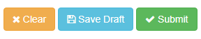
Step 14: This will cause a pop-up that asks if you are sure you want to submit your request, you should select ‘OK’.
If this message does not pop-up you may need to enable pop-ups in your internet settings.
Figure 11 – The request submission pop-up
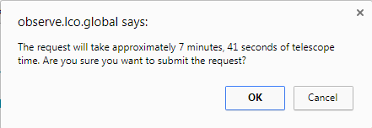
All you need to do now, is come back in a week’s time (or how over long you set your time window as) to retrieve your images.
For further information, contact support@faulkes-telescope.com

