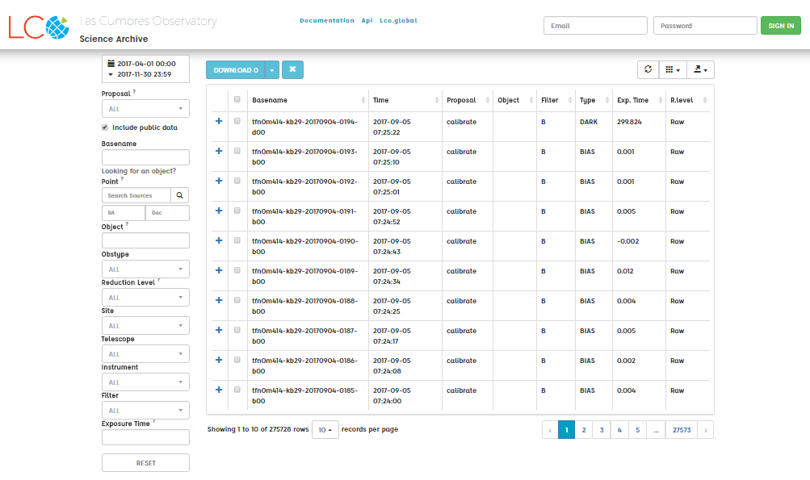
1
8
7
6
5
4
3
2
11
10
9
12
13
14
15
17
16
Accessing the LCO Science Archive

- Signing In
You should begin by signing in to the archive using the same username and password you use to access the observatory portal.

- Date (calendar)
This specifies the time period from which results will appear. The default is this semester and there are several other pre-defined date ranges to choose from. If you need a more specific time range, choose "Custom Range" or the easiest option is to select “All Time”.

- Proposal
This is the proposal from which the observations are made. If you are logged in, your proposals (all beginning with FTP) will appear at the top, under ‘My proposals’. However, we recommend leaving this on ‘All’.

- Basename
This is the name of the file that is created when your image is taken. We don’t recommend using this search field.

- Point
The point field allows you to search for an object by its position on the sky. Entering an object name (eg. M42) in the Lookup field will use an online service to search for the object, and populate the RA and Dec (coordinates) search fields automatically. You can also manually enter a position.

- Object
This searches for an object as it is named in the FITS header. It is not an exact match and we do not recommend using this search box.

- Obstype
This refers to the type of observation you are looking for. You will want the ‘EXPOSE’ option which describes an image exposure.

- Reduction Level
This describes how much processing the data has been through. You will want to select ‘Reduced (BANZAI)’.
Raw files have undergone no processing and Quicklook files have undergone processing but only with calibration frames that were available at the time. Reduced files have undergone processing with the most suitable calibration frames and will show the most clear cut image of your target.

- Site
This is the telescope site at which the observation was made:
lsc: Chile Cerro Tololo Interamerican Observatory
bpl: California Back Parking Lot
coj: Australia Siding Spring Observatory
cpt: Sutherland Astronomical Observatory
elp: Texas McDonald Observatory
ogg: Hawaii Haleakala Observatory
sqa: California Sedgwick Reserve
tfn: Tenerife Teide Observatory

- Telescope
This is the telescope class with which the observation was made:
0m4 options are the 0.4-metre telescopes
1m0a is the 1-metre telescopes
2m0a is the 2-metre telescopes

- Instrument
This is the camera that was used to take your image. It is unlikely you will know this and there are a lot of options! You should leave this set to ‘All’.

- Filter
This is the filter that was used when making your observation. If you have done a colour image you will want to select ‘B’, ‘V’ and ‘R’ for blue, green and red (make sure you choose the ones in Caps Lock). However if you have taken your images on a 0.4-metre telescope you will need to select ‘rp’ for red. You can only search each filter individually.

- Exposure Time
This is the exposure time of your observation in seconds. This will retrieve images with exposures equal to or greater than the value you input.

- Reset
If you want to reset all the fields in your search, click this button.

- Expanding Selection
By clicking on the + sign next to an image you can see a preview of what the image looks like and what calibration was carried out.
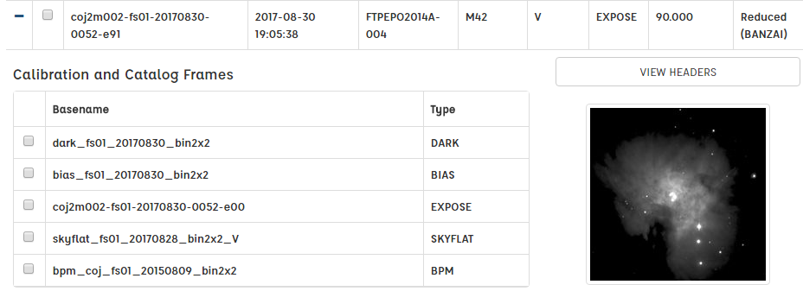

- Downloading Data
If you want to download images, tick the small box to the left of the Basename of the image(s) you want and click the blue ‘Download’ button.

- Refresh, Table and Export
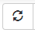This is the refresh button, it will reload the data in the table whilst preserving the search filters you have set.
Here you can select which columns you want to be displayed in the data table. Some columns are hidden by default.
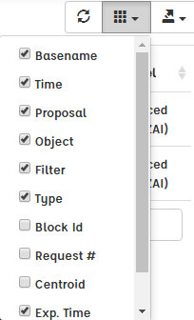

Here you can export the table of data in a variety of formats.
